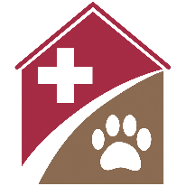 | Shelterly Quick Reference  Notifications

Summary
Shelterly provides opt-in email notifications for the following:
- Creation of a new Service Request (SR) in an incident
- Creation of a new Dispatch Assignment (DA) in an incident
- Addition of a new Shelterly user to the organization
All notifications are made by email, to the email address that you use to login to Shelterly.

New SR Created
To subscribe to Service Request (SR) notifications:
- Open the incident for which you want to receive notifications.
- Select the HOTLINE module.
- Click on the bell icon next to the Hotline title at the top of the page.
- To unsubscribe, click on the bell icon again.

New DA Created
To subscribe to Dispatch Assignment (DA) notifications:
- Open the incident for which you want to receive notifications.
- Select the DISPATCH module.
- Click on the bell icon next to the Dispatch title at the top of the page.
- To unsubscribe, click on the bell icon again.

New Shelterly User Added
All Shelterly users who have User Permissions for a given organization will automatically receive an email whenever a new user is added to that organization.

